Health and Safety Questionnaire –
Physical Activity Readiness Questionnaire (PAR-Q)
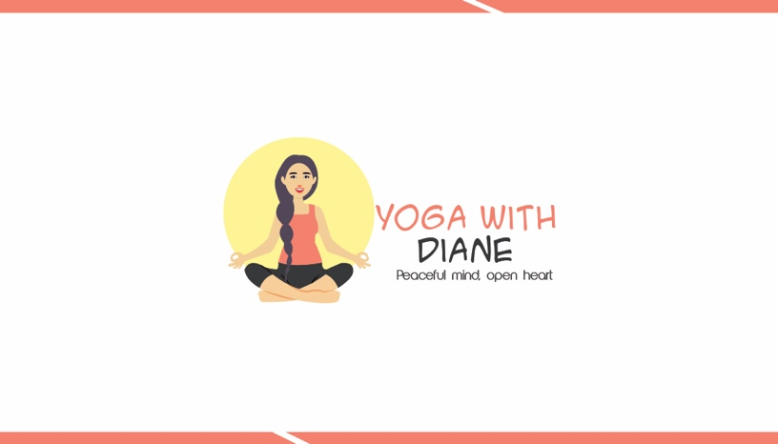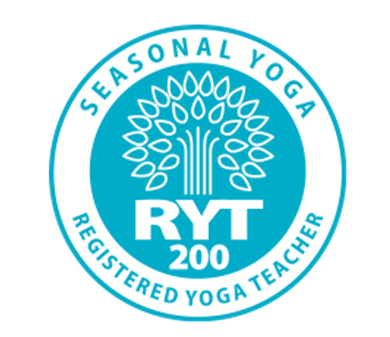
Please forward this completed ParQ form to either
- yogabydiane@gmail.com
- Church Elder Mrs Sandra Burt at the Sunday Service
- In class attendance to Yoga Teacher
Title:____First Name _________________________Surname _________________________ Address:_________________________________________________________________ _______________________Post Code__________Mobile Tel______________________
E-mail address:_______________________________Age:______ Male/Female ________
Medical history
- Have you ever suffered from heart trouble? YES / NO
- Are you presently taking any form of medication? YES / NO
If yes, please state ...............................................................................
- Do you suffer from chest pains? YES / NO
- Do you ever have spells of dizziness or feel faint? YES / NO
- Have you ever had either high or low blood pressure, and/or high cholesterol level?
If yes, please state ...............................................................................
- Have you ever had asthma, chronic bronchitis or any other
chest ailments? If YES Please indicate which: YES / NO
- Do you suffer from back pain or any orthopaedic problem? YES / NO
If YES please indicate which:
.....................................................................................................
- Do you suffer from severe headaches or migraines? YES / NO
- Are you recuperating from a recent illness/operation or injury? YES / NO
If YES please expand:
.........................................................................................................
- Have you any medical condition that we should be aware of?
- Are you pregnant? If yes, how many months?
- Is there any history of heart disease in your immediate family
(under the age of 55)
- Do you have any of the following problem areas?
Neck/Shoulder |  | Sacroiliac Joint |  | Ankles
Upper Back |  | Pelvis/Hips |  | Feet/Toes
Mid Back |  | Sciatica |  | Arms/Elbows
Lower Back |  | Knees |  | Wrists/Hands

COVID -19

HAVE YOU HAD COVID-19?
If yes, when?

HAVE YOU HAD THE VACCINE?
If yes, when?

Have you had one jab or two? Any booster vaccine?

IF YOU SAID YES TO HAVING COVID-19...
Have you experienced what you consider to be any signs or symptoms of Long-COVID?

If not, have you noticed any changes to your normal level of energy, physical activity or exercise that has been altered or seems to be worsened since your exposure to the virus?

It goes without saying that if you are attending the class then it is assumed that you adhering to the guidance set out below by Public Health Scotland regarding Covid-19:
No-one should leave home to participate in an exercise class if they, or someone they live with, has any of the following:
- A high temperature and or/body aches
- A new, continuous cough and/or difficulty Breathing
- A loss of, or change to, their sense of smell or taste
- Headache, Sore Throat
- A positive test result on lateral flow and/or PCR and or within an isolation period
- A pending Covid-19 test
Should an individual have demonstrated any such symptoms, they must follow NHS Scotland, ScotGovUk and PHS guidance on self-isolation.

I have read, understood and accurately completed this questionnaire. I confirm that I am voluntarily engaging in an acceptable level of exercise, and my participation involves a risk of injury,

Signature:………………………………………………………………………………………………………………
PrintName:……………………………………….……………………………………………………………………
Date:…………………………………….....

PLEASE NOTE: If you answered YES to any of questions 1-13 plus COVID-19 annex, you are advised to seek medical advice/approval before commencing an exercise induction or exercise programme.
I have been informed both verbally and in writing that if I answer YES to any of questions 1-13 plus COVID19 ANNEX of this questionnaire, I should seek medical advice/approval before commencing an exercise programme and/or induction. If I wish to continue without such advice I do so entirely at my own risk and other others. I confirm that I have read, fully understood and answered the above questions honestly. I understand that my Yoga Teacher cannot be held responsible for any injuries or ill health arising from my participation in the exercise programme.
Having answered YES to one of the questions above, It is assumed that by signing this form, you have sought medical advice and your GP has agreed that you may exercise.
NOTE: This par-q becomes invalid if your condition changes so that you would answer yes to any of the questions above and not disclosed..
Signed:_____________________________________ Date:__________
Print Name: _________________________________

Yoga Informed Consent Form
I hereby state that I have read, understood and answered honestly the questions on the Physical Activiti Readiness Questionnaire (PAR-Q). I wish to participate in physical activities that will include a Yoga warm-up preparation phase involving standing and lying exercises and a main mat-based yoga/t’ai chi session with floor-based exercises. These could involve use of small equipment such as a blocks, Pillows or strap belt/bolsters. The session will also include flexibility and breathing exercises.
There exists the possibility of certain dangers when exercising; abnormal blood pressure, fainting, irregular/fast or slow heart rhythm. Whilst every care will be taken to ensure your safety it is impossible to predict the body’s exact response to exercise. Therefore, it is important that you provide the correct information on the PAR-Q form to minimise any risk. It is essential that you make the instructor aware of any changes to your medication or health.
I realise that in participating in these activities I may be at risk of injury and even the possibility of death. I hereby confirm that I am participating voluntarily.
Client’s Name
Client’s Signature Date

Instructor’s Name
Instructor’s Signature Date

Code of Conduct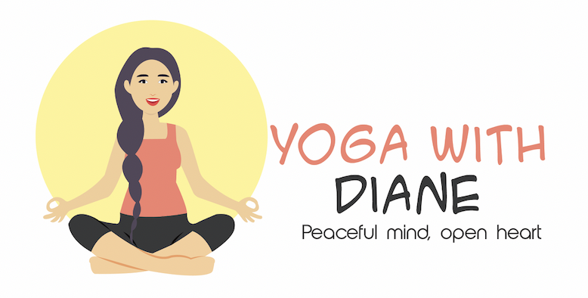

As a class participant I agree to: | Yoga teacher agree to:
Be on time for all sessions | Be on time for all sessions
Attend sessions if paid in advance. Please note that all purchases are non-refundable and non-transferable. | Start and end sessions agreed time. Announcing any changes to class online and at church sessions
Taking responsibility for personal belongings. | Give feedback and guidance throughout the class. Where not possible, answers questions outside of class time by phone/meeting or other means
Have respect and behave responsibility towards others inside the class venue | Discuss issues in related to learning, offering an appropriate amount of time for helping any participant who needs it.
Be always honest and act with integrity. Any behavior likely to cause offense or harm to others will not be tolerated without limitation. This includes offensive and/or racist language or behavior discrimination or prejudice, harassment of others, disruptions to the work or recreation of others and bringing in or use of alcohol or drugs during the class | Be honest in communications with class participants and always acting with integrity alongside the yoga ethics
Participate in the class and take rest where need be when teacher notifies in class. Inform Teacher of any existing injuries or pre-existing conditions before class if not mentioned in Par-Q form. | Allow class participants to express opinions after class, ask for requests feedback or anything that comes up during the class

As a class participant I agree to: | Yoga Teacher agree to:
Have respect for the efforts of the teacher by using mobile phones during a class, not talking/lying down for extended periods of time(unless its relaxation pose)Ha and generally paying attention during the class | Have respect for the diversity and accessibility of class participants learning styles and accommodate sessions accessible to all. Using during a class visual kinaesthetic auditory and handouts for factsheets. Offer regular breaks if participant needs to take rest.
Comply with the Health & Safety regulations of the venue. Always behave in manner that does not put yourself or others at risk. Corridors and stairways which are provided for the safe passage of people using the venue should not be obstructed with bags or personal belongings | Comply and explain Health and safety rules of the venue. Ask about any illnesses/injuries prior to class in advance.
Ask teacher for help or advice when needed during agreed time. Being sure not to ask for or expect them to spend their time or attention beyond what is appropriate or fair. | Be available for support and help at agreed times

Please ensure you have read all the above points before signing below:
I agree to abide by the code of Conduct as above during any class given by YogaByDiane:
Class participant
Yoga Teacher
Date

